Lab 1 Assignment

* List 5 characteristics for red team

1. penetration testing.
2. network exploitation.
3. vulnerability assessment.
4. Effective Communication.
5. **Operational Security**: Red teams implement strong operational security practices to maintain stealth and avoid detection.

* List 5 characteristics for blue team

1. **Defensive Expertise**: Blue teams focus on implementing and managing security measures to protect an organization’s systems and data. They have deep knowledge of defensive technologies, such as firewalls, intrusion detection systems (IDS), and antivirus software, and are skilled in configuring and maintaining these tools.

ii **Incident Response Skills**: Blue teams are proficient in responding to and managing security incidents. They develop and follow incident response plans to quickly detect, contain, and mitigate threats, minimizing damage and restoring normal operations as efficiently as possible.

iii **Continuous Monitoring**: Blue teams engage in ongoing monitoring of network and system activity to detect and respond to potential threats. This includes analyzing logs, conducting regular vulnerability assessments, and using security information and event management (SIEM) systems to identify anomalies and potential breaches.

iv **Threat Intelligence**: Blue teams utilize threat intelligence to stay informed about emerging threats and attack techniques. They leverage this knowledge to update their defenses, anticipate potential attacks, and adapt their security posture to counter new and evolving threats.

v **Collaboration and Communication**: Effective communication and collaboration are crucial for blue teams. They work closely with other departments and teams within the organization to ensure that security policies are implemented and followed. They also provide training and awareness programs to educate employees about security best practices and potential risks.

* List 5 characteristics for purple team

i **Collaborative Approach**: Purple teams bridge the gap between red (offensive) and blue (defensive) teams, fostering collaboration and communication between them. They work together to enhance overall security by integrating the insights from red team simulations into blue team defensive strategies.

ii **Integrated Security Testing**: Purple teams facilitate the integration of offensive testing results with defensive measures. They ensure that the red team's attack scenarios are used to inform and improve the blue team's security posture, leading to more effective defense mechanisms.

iii **Continuous Improvement**: Purple teams focus on creating a feedback loop where red and blue teams learn from each other’s activities. They analyze the outcomes of security tests and incidents to continuously refine and improve security processes, tools, and strategies.

iv **Holistic Perspective**: They adopt a comprehensive view of security, combining the offensive tactics of red teams with the defensive strategies of blue teams. This perspective helps in identifying and addressing weaknesses across the entire security landscape, rather than in isolation.

v **Knowledge Sharing**: Purple teams facilitate the exchange of knowledge and skills between red and blue teams. They organize training sessions, workshops, and debriefings to ensure that lessons learned from red team exercises are effectively communicated and applied to strengthen the organization's defenses.

* Ping bpost.be and cnn.com, list three comparison between both outcome

1. The latency is higher for bpost.be. It faster to connect to cnn.com because it takes less time to ping cnn.com as seen on the screenshot below
2. The percentage of packets that are lost during the ping test are the same.
3. Different ipadress.

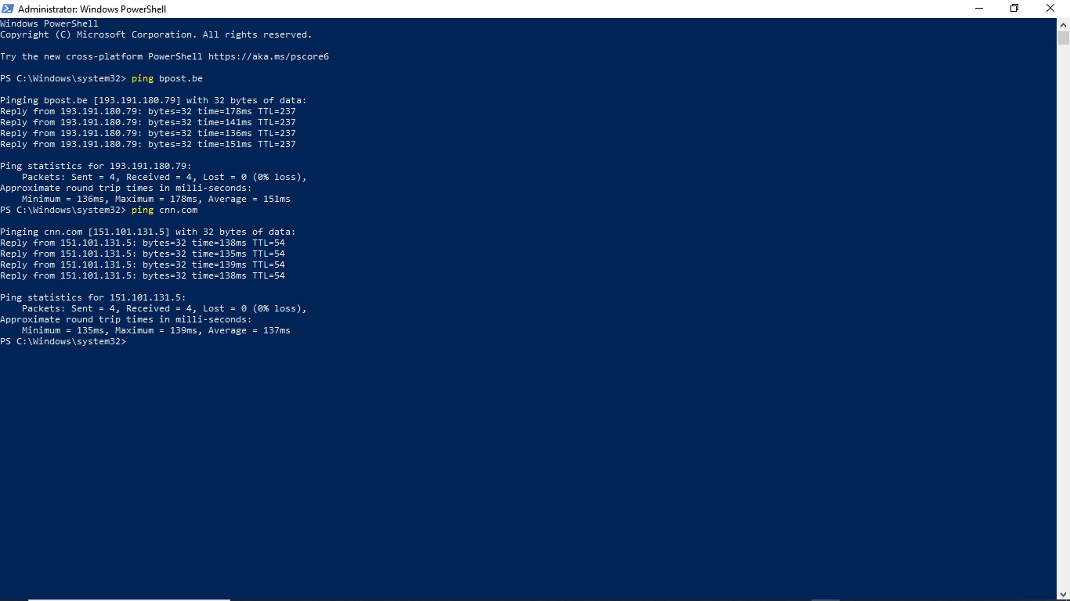

* Tracert cnn.com and bpost.be, from a Red Team’s perspective, analyze the differences between both tracert results for cnn.com and bpost.be.

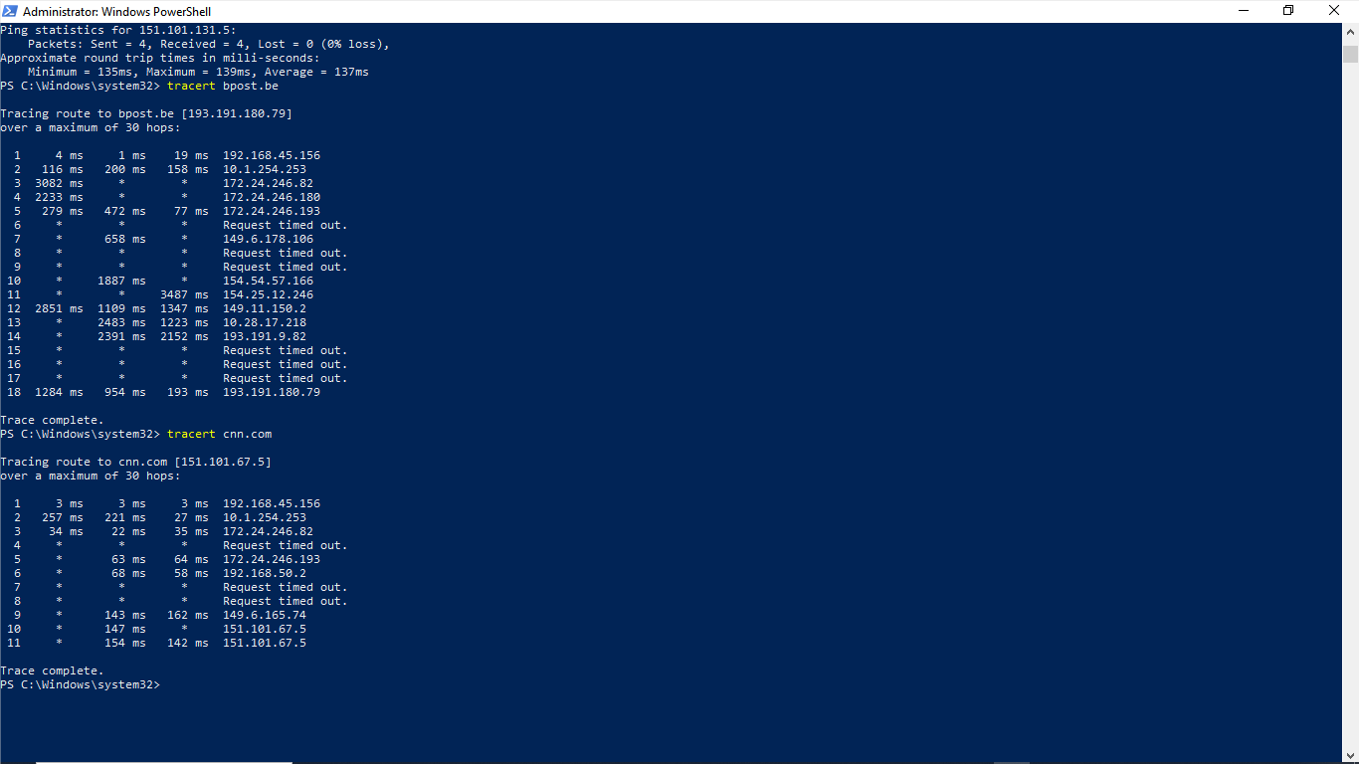

· CNN.com shows a relatively direct and faster network route with minimal security interruptions.

· Bpost.be exhibits a more complex and slower route with numerous timeouts, indicating stronger security measures that could hinder reconnaissance activities